Rainbow Chard Information Pack
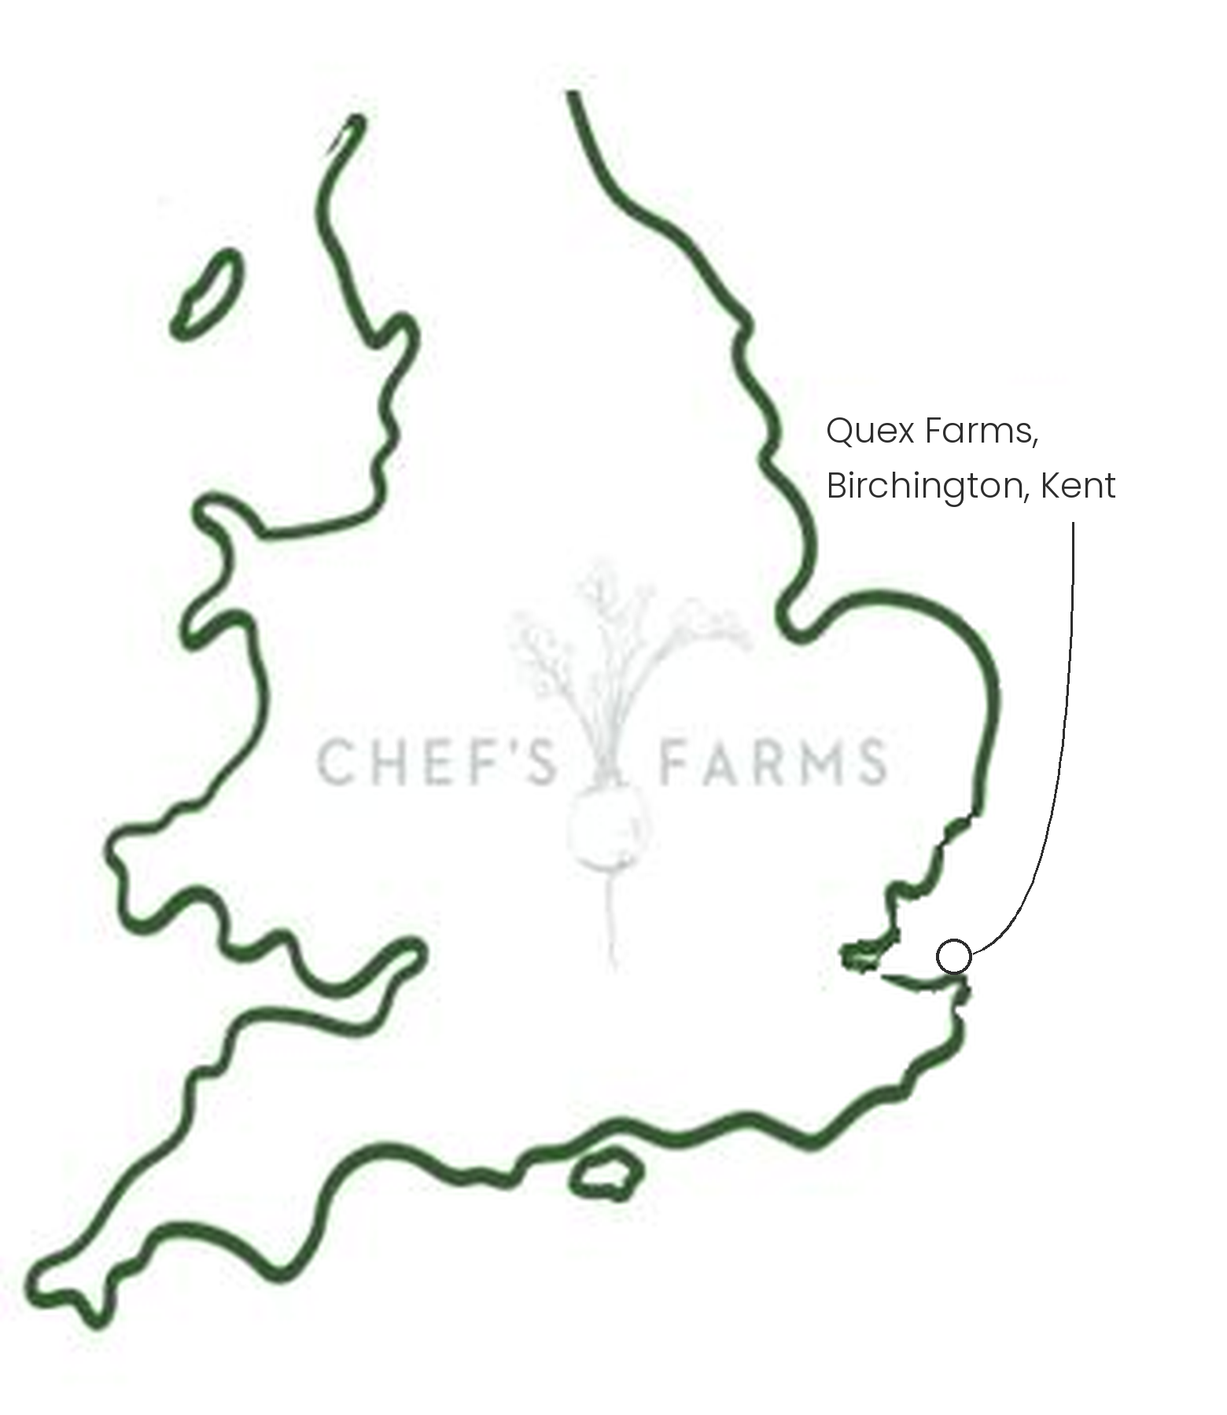
Introduction
Chard is a close relative of beetroot, grown for its leaves and stems rather than its root. Rainbow chard is a mix of varieties with red, pink, orange, yellow and white stems, each with a slightly different earthy sweetness.
Farm Information
Our rainbow chard is grown by Jack Scott and the team at Quex Farms in Birchington, on the Isle of Thanet in Kent, who also grow our purple sprouting broccoli and spring onions.
Thanet's mild, coastal climate gives leafy crops a long growing season. Chard is a cut-and-come-again crop: rather than lifting the whole plant, the outer leaves are cut by hand and the plant keeps producing new ones from the centre, so a single planting can be picked for months.
Being a beet rather than a brassica, chard is also a useful crop in a rotation. It doesn't share the cabbage white, clubroot and other pests and diseases that build up under brassicas like the farm's PSB, so growing it in between gives the soil a break and helps keep those problems down.
We are proud to work with Jack and the team.
More
Chard is at its best from early summer through to late autumn. Separate the stems from the leaves, as the stems need a few minutes longer; slice and sauté them first, then wilt the leaves in at the end. Cook the colours separately if you want them to stay bright.
Nutritionally, chard is an excellent source of vitamin K, and a good source of vitamins A and C, magnesium and potassium. The colours in the stems come from betalains, the same pigments that give beetroot its colour.
Media
See shared album

